ETM (Engineering Test Mode) for M3 IPC – CGEA 1.3

Functional Description

Engineering Test Mode (ETM) is a level of operation within the cluster that is intended to be used by its engineering and service activities. It is not intended to be used by the customer.

ETM is a series of display screens that display data used by the cluster.

Interfaces

Interface Context Diagram (I/O Block Diagram)
Figure 1 ETM (Engineering Test Mode) for M3 IPC Context Diagram
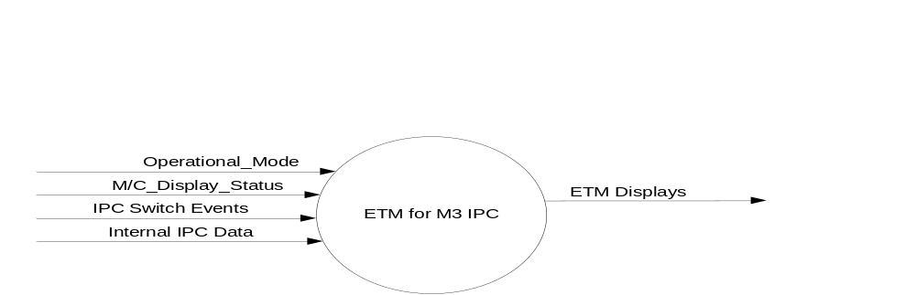

Inputs

- INTERNAL:
- Operational_Mode
- IPC Switch Events
- M/C_Display_Status
- Internal IPC Data

Outputs
- ETM Displays

Function/Performance

Operational Modes

Mode | Differentiating Vehicle Conditions
Sleep Mode | ETM Off
Limiting Mode | ETM Off
Normal Mode | ETM Off/On
Crank Mode | ETM Off/On

Voltage Levels

Refer to the Cluster Features table located in the Operational Modes and Voltage Range Strategies Section in this SPSS.

Human-Machine Interface

Visual

Indicator Graphics / Display Format

Indicator Color Coordinates

Reference the program wallpapers and the ETM Text file.

Indicator Characteristics

Reference the program wallpapers

Audio

None

Switch Control Logic

Consumer access to the switches shall be as specified in Steering Wheel Switch – 4-Way with Rocker Hotkeys – CGEA 1.3 STSS.

System Accuracy

Within a 100msec of receiving a message that results in a change of state the cluster will update the display to the proper status.

Operation: Performance and Functional

Subsystem Algorithm Flowchart / State Diagram

Operational Description (supports algorithm flowchart /state diagram)

ETM is set to FALSE at Battery Connect and Operational_Mode = Limited and Operational_Mode = Sleep

For the M3 IPC, ETM is set to TRUE when the IPC Message Center OK Switch is pressed and held for the first 5 seconds of Operational_Mode = Normal. A M3 IPC is one large display that is subdivided into multiple display areas. The IPC Message Center OK Switch is the OK Switch on the Steering Wheel. Typically, this is the input in the SteWhlSwtchOk_B_Stat signal.

For the M3 IPC, ETM is set to FALSE when the IPC Message Center OK Switch is pressed and held for the first 8 seconds of Operational_Mode = Normal.

For the M3 IPC, ETM is set to FALSE when ETM is TRUE and an ETM Screen is the current Display and the IPC Message Center OK Switch is pressed and held for 3 seconds in Operational_Mode = Normal

For the M3 IPC, the ETM Screen is displayed in a box defined as Zone C1.

For the M3 IPC, all warnings and their use of the button presses will have a higher priority than ETM. When an ETM screen is displayed, ETM will have priority use of the Up/Down/OK/Back button presses higher than the non-warning features of the M3 IPC.

For the M3 IPC, when ETM = TRUE, the letters “ET” shall be treated as a General RTT and will be displayed in the General RTT Bank.

A Down Arrow Press event on the Message Center Switch while an ETM Screen other than ET420A (AFE_Bias_Factor Screen) is the current Display will cycle to the ETM Screen with the next higher numbered Message ID unless the current is the ETM Screen with the highest numbered Message ID in which case the ET100 becomes the new ETM Screen to be displayed.

An Up Arrow Press event on the Message Center Switch Set while an ETM Screen other than ET420A (AFE_Bias_Factor Screen) is the current Display will cycle to the ETM Screen with the next lower numbered Message ID unless the current is ET100 in which case the ETM Screen with the highest numbered Message ID becomes the new ETM Screen to be displayed.

For the M3 IPC, an IPC Message Center Back Switch Press while an ETM Screen is the current Display will result in the removal of the ETM Screens from the Zone C1 area.

For the M3 IPC, an IPC Message Center Back Switch Press while ETM = True and the M3 IPC current state is not Settings, Navigation, Phone, Media or HUD Settings will result in the display of ET100 in the Zone C1 area.

The required ETM Screen Display information is identified in the “ETM Text” file. All of this information must be included in the ETM screen flow. The “ETM Text” file also contains the recommended sequence and display format. ETM Screen ET420A is not included in the sequence and can only be displayed via an OK press while displaying ET420. Additional screens can be added to the ETM sequence with the approval of the DI Application Engineer. Each IPC program must create a program specific “ETM Text” if it uses a different ETM Sequence or ETM screen format than specified in the recommended “ETM Text” file.

All ETM screens can be in English regardless of the active language as per Display_Language_MC.

The ETM feature must be functioning in both pre-production and production source code. This feature shall be in production source code unless a waiver is obtained from the DI Application Engineer.

Function Safety Classification (EMC)

Class B

Memory Storage

Parameter Name | Description | Value at  Battery Connect | Value at Module Wake-up
Internal IPC Data | Numerous variables that are used by the IPC software. | See appropriate Section for each variable. | See appropriate Section for each variable.
ETM | State indicator for Engineering Test Mode | False | False
M/C_Display_Status | State Indicator to identify which text is currently being displayed on Message Center display. | See Message Center SHMI Section | See Message Center SHMI Section
IPC Switch Events | Events that are indicated as per the switch interface for the Message Center. | See MC Switch Section | See MC Switch Section
ETM Displays | Display content for the ETM screens and their associated ETM sequence number. | See ETM Text file. | See ETM Text File.
ETM_Pointer | The ETM sequence number of the ETM Display that will be displayed if ETM = True and the display scheduler needs to display an ETM Display | ET100 | ET100
Operational_Mode | 4 state indicator for cluster operational mode | Limited | Limited, Normal or Crank

Reconfigurable Telltale

“ET”

Prove Out

Not applicable

Message Center Msg

Refer to ETM Text Section of this SPSS.

Error Handling

None

Diagnostics

Self Test

None

Engineering Test Mode

This Section defines ETM

Part II Performance

None

Reference Specification

ETM Text File

Revision History
SPSS Module Revision History

Revision Level | Name | Change Description | Date
1.0 | T. Cwik | Initial Release | 8/11/2014
2.0 | T. Cwik | Updated to achieve a common approach for the AFE Bias Factor Update with the non-M3 IPC.  1.3.5.2.8 – Added “other than ET420A (AFE_Bias_Factor Screen)”.  1.3.5.2.9 – Added “other than ET420A (AFE_Bias_Factor Screen)”.  1.3.5.2.10 – Removed “other than ET420 (AFE_Bias_Factor Screen)”.  1.3.5.2.12 – Added “ETM Screen ET420A …”. | 8/21/2014
3.0 | T. Cwik | Update to match IPC M/C STSS for M3  1.3.5.2.5 – Changed Zone E to Zone C1  1.3.5.2.10 – Changed Zone E to Zone C1  1.3.5.2.11 – Changed Zone E to Zone C1 | 8/27/2014

